Faye Struble

Number Systems and Digital Logic

* 1. 128 bytes
  2. 256 bytes
  3. 512 bytes
  4. 1024 bytes
  5. 2048 bytes

1. MSB and LSB
   1. 100000

The MSB is the bit that is the farthest to the left in the binary number and it 2^5 or 32. In this case is would be the 1 and this indicates the binary number is negative. The LSB is the bit the farthest to the right so it the LSB is equal to 1.

* 1. 11101010

The MSB is the farthest to the left in the binary number and it is equal to 2^7 or 128. The LSB is the farthest to the right, so the LSB is equal to 1.

1. NAND
   1. 01010
   2. 11010
2. XOR
   1. 01000
   2. 10010
3. The bit masks for the AND operator is used to get to certain bits within a byte of data. It is kind of a way to simplify bits and apply a mask to the bits in the value. If both bits in the same input values were 1 the result is 1 in the same bit position.
4. Hexadecimal to binary
   1. 11101000100001
   2. 1000111110000
5. Hexadecimal to decimal
   1. 250
   2. 16
6. Decimal to hexadecimal
   1. 67
   2. D2

Programming Questions

1. 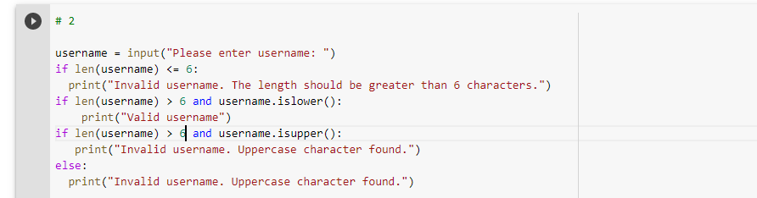

<https://www.programiz.com/python-programming/methods/string/islower#:~:text=Join-,Python%20String%20islower(),uppercase%20alphabet%2C%20it%20returns%20False>.

1. The if statement needs to be indented once as stated in the hint. The print statement also needs to be indented twice to run the code.

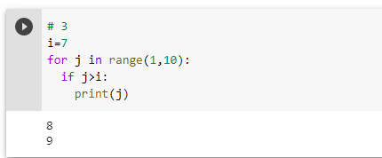

1. Power

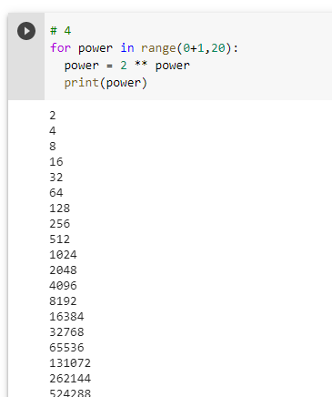

1. Code sample
   1. 10 represents the starting value in the range of numbers.
   2. 50 represents the ending value in the range of numbers.
   3. 4 represents the intervals of the range of numbers that go from 10,14,18,22.
   4. It prints out the product of the intervals such as 10\*10. It would print 100, 196, 324, 484 and so on.
2. The values 3 and 12.429 would be printed. 3 is printed because it is dividing a which is 87 divided by 7, but the % operator asks for the remainder of quotient. The remainder is 3. The 12.429 is printed because a is divided by 7 with the / operator which returns the decimal of the quotient. The decimal is 12.429. This is a floating point value.

Computer Organization

1. There are 16 CPU registers provided for this architecture.
2. There are 256 unique addresses for this architecture because the integer range is from 0 to 255.
3. They are made up of 2 bytes.
4. The opcode is made up of the first 4 bits and the operand is made up of the last 12 bits.
5. LOAD register 5 with the bit pattern found in the memory cell at address B3.
6. LOAD the register 5 with the bit pattern C3.
7. OR the bit patterns in registers B and 2 and place the result in register 1.

General Awareness

What ergonomic guidelines are you currently following?

I do not rest my wrists or my elbows on any sort of surface. My fingers stay in a straight-line with my forearm. I grip my mouse softly, so I don’t strain my wrist. I keep my monitor at the perfect heigh which is slightly below eye level and in front of me. I keep my thighs parallel to the floor in my chair and my feet on the floor. My hips remain in a good position, and I keep my shoulders back when I sit. I do have an ergonomic mouse the helps prevent wrist strain.

What guidelines are you not following?

I do not use a foam pad to rest my wrists or forearms. My keyboard I probably in too high of a position because it is not near my lap. I also need to reduce the glare of my monitors because they can be too bright sometimes. I do not have a very good chair because it doesn’t have any back arch support.

List all changes that you plan to make over the next few weeks to improve your posture.

I need to get something to support my wrists if I need to wrest them. I need to figure out a way to lower my keyboard and possibly get a lap desk. I will lower the brightness of my monitors and turn night mode on. I heard blue or orange light helps. I might get a new chair or find a towel to give better support to my lower back.

Extra Credit: Feedback Questions

1. I would say at the beginning of the course I was at a 1 or 2 in my programming ability. I would say I am at a 5 or a 6 in my programming ability, but I still have a lot to learn still about Python.
2. I would say the difficulty of the labs are a 5 or a 6. I would like the labs to be more difficult. I would also like to do more programming challenges and programming activities.
3. I am excited to learn more about architecture and different software engineering tools. I am also super interested in databases within different languages such as SQL.

Colab:

<https://colab.research.google.com/drive/1Uxs3XBc18I6MMZdhT6-VTXRaMawcDMMB#scrollTo=iH3PJXphQ2Fd>